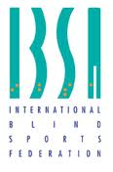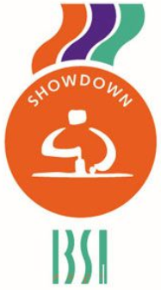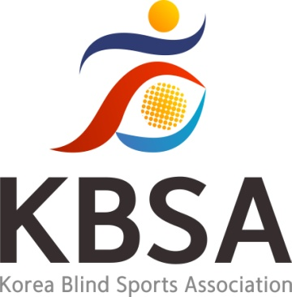

**IBSA SHOWDOWN SPORT COMMITTEE**

in cooperation with

**KOREAN BLIND SPORTS ASSOCIATION**

presents

**ASIA NATIONAL REFEREE COURSE**

Seoul, 5th – 8th December 2023

**About Showdown – Sports Committee**

**Chair**

**Artūrs Kalniņš**

E-mail: showdown.chair@ibsasport.org

**Vice Chair**

**Elena Santini**

E-mail: elena.santini1984@libero.it

**Referees' Representative**

**Jonas Riester**

E-mail: jonas.riester@web.de

**Coach Representative**

**Akseli Makkonen**

E-mail: akseli.makkonen@gmail.com

**Athletes' Representative**

**Christoff Eilers**

E-mail: christoff.eilers@gmail.com

**Asia Representative**

**Kang Ho Yong**

Phone: +82 02 400 6335

E-mail: [ghy3090@hanmail.net](mailto:ghy3090@hanmail.net)

**Organizer for the Korea Blind Sports Association**

**IBSA KOREA**

**A-1301 ,583, Yangcheon-ro, Gangseo-gu, Seoul, Republic of Korea**

Tel : +82 02 400 6335

web : http://kbsa.koreanpc.kr/

E-mail: kyungk21@naver.com

We look forward to meeting and welcoming you to Korea.

Should you have any questions regarding this event, please contact us at: kyungk21@naver.com

**Important Registration Deadlines**

*PLEASE RESPECT ALL DEADLINES AND RULES DETAILED BELOW*

Entry forms submitted after the deadline will not be accepted and will result in the IBSA Member not entering the Event.

Submit the final entry after the participant is confirmed.

If there are many participants, participation may be restricted.

**1. First Entry Submission Deadline: November 20, 2023**

**2. Participant Confirmation Date: November 20, 2023**

**3. Final entry Submission Deadline: November 25, 2023**

**Entry Fees**

**Entry Fee: $350.00 per person**

**Entry Fee Payment Deadline: November 29, 2023**

Participant will be charged an entry fee of $350 dollars.

The entry fee includes accommodation* and meals from 4th to 9th December 2023, ground transportation to/from approved airports to the Official Hotel and Referee Course venues.

The entry fee does NOT include air transportation fees for delegation members. Delegations may only stay at the official hotels during the Referee Course period.

*Rooms will be assigned to 2 people per room. If you wish to request a single room the extra fee is $100.

**Arrivals & Departures**

We will pick up your Delegation on the following days at the designated airports.

If arriving on a different day or airport than what is listed below, you are responsible for transportation to Incheon International Airport.

**Arrival on December 4th, 2023**

**Departure on December 9th, 2023**

**Airport Information**

**Incheon International Airport**

Terminal 1 272, Gonghang-ro, Jung-gu, Incheon, Republic of Korea 22382

Terminal 2 446, Je2terminal-daero, Jung-gu, Incheon, Republic of Korea22382

For more information, visit [https://www.airport.kr](https://www.airport.kr/)

**Event Venue**

**Hotel Bernoui ( Seminar Room)**

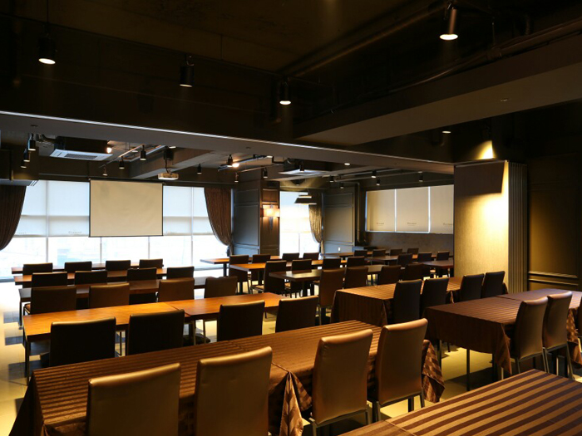

**Hotel Information**

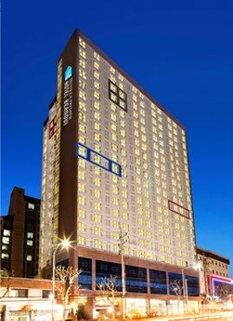

**Hotel Bernoui**

**229, Gyeongin-ro, Guro-gu, Seoul, Korea**

**http://www.hotelbernoui.com/**

* Each nation must provide a credit card to the hotel upon check-in for any incidentals (room service, etc.) or damages.

If you are a member of a participating delegation or have questions about accommodations, please email [kyungk21@naver.com](mailto:kyungk21@naver.com).

**Course Information**

The National Referee Course and Exams will be held in English.

Participants have to speak English well or, if not, must be accompanied by an interpreter at their own expenses.

**Showdown National Referee Course Program**

**5th December 2023**

09:00-10:00 Presentation and Introduction to Showdown

10:00-11:00 Explanation of the Rules

11:00-11:30 Break

11:30-13:00 Explanation of the Rules

13:00-14:00 Lunch Break

14:00-16:00 Explanation of the Rules

16:00-16:30 Break

16:30-18:00 Explanation of the Rules

**6th December 2023**

09:00-11:00 Explanation of the Rules

11:00-11:30 Break

11:30-13:00 Scoresheet Explanation and Exercises

13:00-14:00 Lunch Break

14:00-16:00 Demonstration and Practice

16:00-16:30 Break

16:30-18:00 Practice

**7th December 2023**

09:00-11:00 Practice

11:00-11:30 Break

11:30-13:00 Practice

13:00-14:00 Lunch Break

14:00-16:00 Practice

16:00-16:30 Break

16:30-18:00 Practice

**8th December 2023**

09:00-10:00 Questions and Answers

10:00-11:00 Written Exam

11:00-11:30 Break

11:30-13:00 Practical Exam

13:00-14:00 Lunch Break

14:00-16:00 Practical Exam

16:00-16:30 Break

16:30-17:30 Practical Exam

17:30-18:00 Evaluation of the exams and Certification delivery