**24th IBSA NINEPIN BOWLING EUROPEAN CHAMPIONSHIP**

**FOR BLIND AND VISUALLY IMPARIED – 09.05 -17.05.2025**

**Veľký Šariš, Slovakia**

**INVITATION and GENERAL INFORMATION**

***Dear friends,***

The **Slovak Association of visually impaired athletes** are pleased to invite your blind and visually impaired nine pin bowling players to take part at **24thIBSA NINEPIN BOWLING EUROPEAN CHAMPIONSHIP FOR BLIND AND VISUALLY IMPARIED, 09.05 - 17.05.2025. Velky Saris, Slovakia**

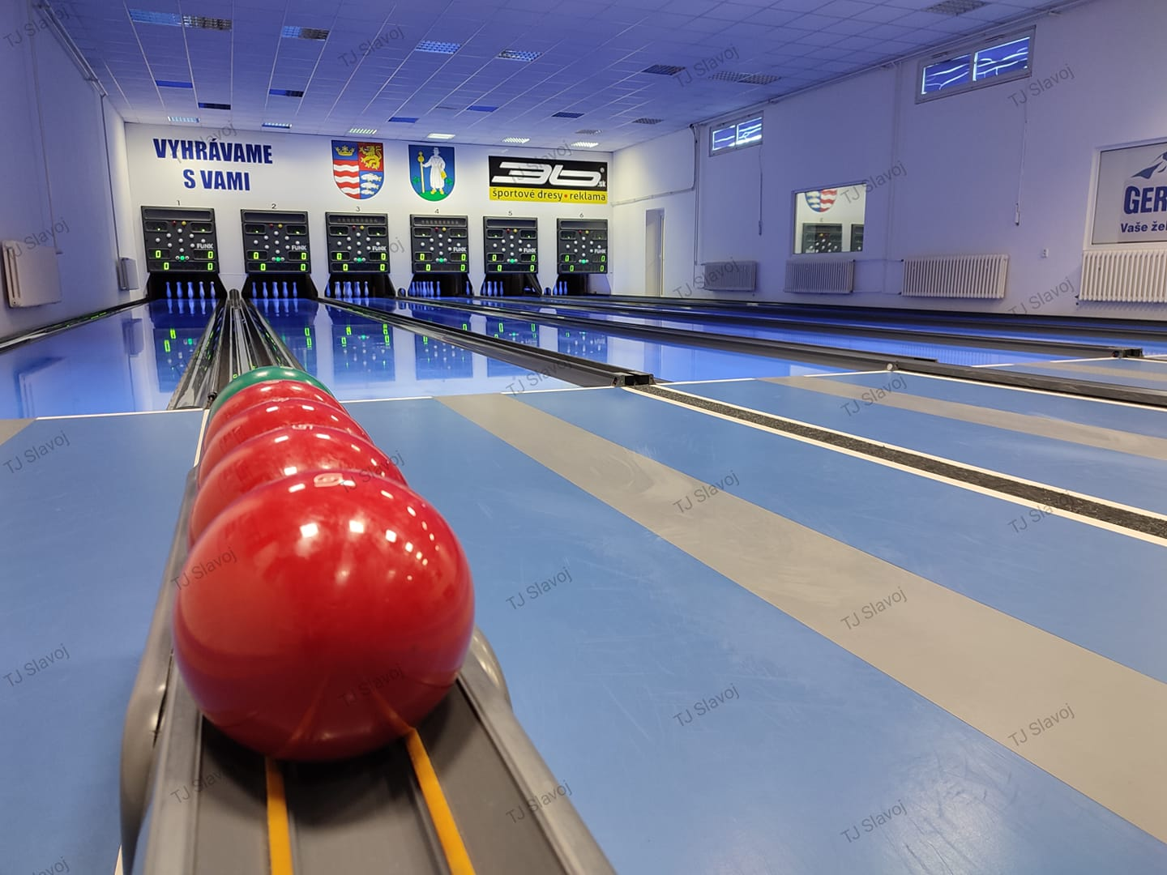

**24th IBSA NINEPIN BOWLING EUROPEAN CHAMPIONSHIP LOC:**

HOST: **Slovak Association of visually impaired athletes (**[**https://sazps.sk/**](https://sazps.sk/)**)**

ADRESS: Kúpeľná 1843/81, 972 01 Bojnice, Slovakia

**All correspondence to LOC should be sent to**  :

Name: Jakub Krako

Email: [sazps@sazps.sk](mailto:sazps@sazps.sk)

Tel: +421907448837

**DATE OF EVENT**:

Arrival date, **09.05.2025.**

Departure date, **17.05.2025.**

Classification dates: **10. - 12.05.2025**

Competition date: **13.05., 14.05., 15.05. and 16.05.2025.**

**HOST CITY : Velky Saris, Slovakia**

**ACCOMODATION**:

**Hotel Lineas, Presov**, Slovakia (11 km to V.Saris)

Budovateľská 14, Prešov

Web page of Hotel: <https://lineas.sk/en/homepage/>

**ENTRY FEES**:

* **__97,00__ EURO/per person/day in Single room**
* **__92,00__ EURO /per person/day in Double room.**
* **__87,00__ EURO/per person/day in Tripple room**
* The number of single rooms are limited, the organizer will give priority to the first bookings.

The entry fee includes participation fee, transport to hotel (from bus , rally or international airport stations , meals full board etc.)

**NINE PIN BOWLING ALLEY INFO:**

**NINE PIN Bowling alley location:**

**NINE PIN Bowling alley, TJ Slavoj, kolkaren, Velky Saris, 6 lanes, Funk**

**Adress.: Zámocká 2, Velky Saris, Slovakia**

**Web page:** [**https://tjslavojvelkysaris.wbl.sk/**](https://tjslavojvelkysaris.wbl.sk/)

**FB:** [**https://www.facebook.com/tjslavojvelkysariskolky?locale=sk_SK**](https://www.facebook.com/tjslavojvelkysariskolky?locale=sk_SK)

**YT:** [**https://www.youtube.com/@tjslavojvelkysaris**](https://www.youtube.com/@tjslavojvelkysaris)

**TRANSPORT**

Nearest Airport: Košice (33 km)

Nearest Train Station: 2 minutes by car

Distance from Hotel to Venue (Kms): 11 km

All participants will start with dinner (09.05.2025) and finish with breakfast (17.05.2025).

**CLASSIFICATION:**

Classification days are: **10.05, 11.05., and 12.05.2024.**

Please read all below and prepare your team for Classification according to the rules. Players must become familiar with rules and procedures of IBSA medical classification:

( <http://www.ibsasport.org/documents/files/68-1-IBSA-Classification-Rules-and-Procedures.pdf>).

**Submission Deadlines**

1. **The First Deadline for Submission** of a **Request for Classification Form** (**by email** to ibsaassist@ibsasport.org ) and for uploading athlete MDFs and supporting medical tests in ISAS is **Febuary 11, 2025**. Submissions received by this deadline, will be given first priority for allocation of a classification assessment slot at the competition. Athletes will be assigned a classification appointment only after the MDF and supporting medical documents have been approved by the classifiers as establishing an UHC (Underlying Health Condition)

**2. Second Deadline:** Submissions received after the first deadline **(and by March 29)** will be allocated a classification slot if available, on a first come first served basis. Athletes will be assigned a classification appointment (if available) only after the MDF and supporting medical documents have been approved by the classifiers as establishing an UHC.

**Submissions received after March 29, will not be reviewed by classifiers or considered for this competition.**

**Medical Diagnostics Form (MDF**) and other required medical diagnostics documentation must

not be older than 1 year. Final second deadline for MDF is 29.03.2025.

**The Classification Process is as follows**

The first step in the classification process is to establish that the athlete has an ***Underlying Health Condition (UHC***) that leads to an eligible vision impairment. This is done by classifiers who review the athlete’s Medical Documentation Form (MDF) and supporting medical documents. This review takes place before the athlete is assigned a classification evaluation appointment. If the information is not complete, or there is not sufficient evidence of an UHC leading to an eligible vision impairment, the athlete will not be scheduled for a classification appointment.

1. Once a UHC is established, the athlete can be scheduled for a classification evaluation appointment.
2. At the classification evaluation appointment, the classification panel will
   1. confirm (or not) the UHC,
   2. if the UHC is confirmed, the classification panel will proceed with a vision assessment to determine
      1. if the athlete meets the minimum impairment criteria,
      2. assign a sport class and sport class status to the athlete

Only athletes competing in this event can be classified.

**IBSA ISAS ONLINE registration of players:**

All players participating in the EUROPEAN CHAMPIONSHIP **2025** , must be registered in the ISAS database and have a current ISAS Active Sport License for **2025** and IBSA Athlete ID

**Entry by number will be: 01 January – 28th February 2025.**

**Entry by Name will be from: 1 March 2025. – 29 March 2025.**

**IBSA FEE**:

* The countries must pay the IBSA Capitation Fee per player. The fee will be paid to LOC of EUROPEAN CHAMPIONSHIP 2025.
* Each IBSA Member Country must have paid 2025 IBSA Membership Fee.

**RULES** :

EUROPEAN CHAMPIONSHIP 2025 will be made according IBSA Nine Pin Bowling Rulebook.

**ANTI DOPING CONTROL**

The event is subject to random doping tests in accordance with IBSA regulations. Athletes should refer to the IBSA Anti-Doping Policy.

Any athlete taking medication subject to doping controls must be in possession of a valid IBSA **Therapeutic Use Exemption (TUE).** For information on IBSA’s anti-doping policies and how to apply for a TUE, go to [www.ibsasport.org/anti-doping](http://www.ibsasport.org/anti-doping). For more info you can contact Juliana Soares at [juliana@ibsasport.org](mailto:juliana@ibsasport.org)

**PAYMENT DETAILS**:

The total entry fee shall be paid into our account not later than 11th April 2025

I inform you that payment will be made only by bank transfer.

The banking details are;

**Bank account no**  SK95 8330 0000 0021 0076 9190

**Swift code :**  FIOZSKBAXXX

**Account beneficiary address:**

**Name:** Slovenská asociácia zrakovo postihnutých športovcov

**Address** Kupelna 1843/81, 97201 Bojnice Slovakia

**Bank name and address**

**Name: :** Fio banka, a. s., pobočka zahraničnej banky,

**Address:** Dunajská 1, 81108 Bratislava, Slovakia

**MEDICAL INSURANCE:**

All members of your delegation MUST have an international travel and personal accident insurance.

**KEY DATES**

* **First entry form Number ISAS Online: 28th February 2025.**
* **Entry form by name ISAS Online: 29th March 2025.**
* **Total entry fee payment: 11th April 2025**
* **Final entry form, Accommodation form, Travel form: 11th April 2025**

**Classification Key Dates:**

**First Deadline for Submission** of **a Request for Classification Form** (by email to ibsaassist@ibsasport.org ) and for uploading athlete **MDFs and supporting medical** tests in ISAS **February 11, 2025**.

**Second Deadline:** for uploading athlete **MDFs and supporting medical tests** in ISAS

**March 29, 2025.**

**All the best and see you in Slovakia**

**President of Local organizing committee: Václav Trnka**