Official Invitation
The International Blind Sports Federation and The Egyptian Blind Sports Federation
Invite all IBSA member Federations to the:
16th IBSA World Powerlifting & Bench Press Championships
For Blind and Visually Impaired Athletes
Alexandria, Egypt
October 1 – 8, 2022

Contest Director: Mr. Mahmood Elsherbeny mobile: +20 100 0571716
Championship and Technical Secretary: Dr.Hossein Farzanefard E-Mail : hosein.farzanehfard@gmail.com
IT & Scoring Manager: Sergio Centeno E-mail: sergiocentenorodriguez@gmail.com Tel: +1.787.607.9895
All Correspondence and Visa: Please send all correspondence and visa request to Dr. Ahmed Owin email: egyblindsports2016@gamil.com mobile: +201063325600
Championship Host City: Alexandria, Egypt

Championship Dates: October 1 – 8, 2022

Championship Venue: pharos university - Alexandria - Egypt

Championship Hotel: The Grand Plaza Hotel Alexandria.

The organizer will not be responsible for any hotel bills of the participating IBSA Member Nations. Each Team manager will be responsible. All rooms must be booked by the final August 20th, 2022. After the deadline the organizer cannot guarantee room accommodations.

Special Note: The cost of the hotel will be:
Single room: 140 Euro per person per night including full board meal
Double room: 120 Euro per person per night including full board meal
Each federation will be required to pay 150 Euros, per athlete. The 150 Euros will cover participation fee, Anti-doping fee, capitation fee for the championship. All athletes, coaches, referees, or officials from each federation must stay in the official hotel during the championship.

PCR test is mandatory 48 hours Before coming to Egypt
100 euros per PCR Test Per person PCR tests are predeparture
Anyone with a positive test MUST stay in the quarantine provided by the LOC. The cost must be paid by the National Federation.
If a positive person takes another test during the quarantine period:
If positive: Restart quarantine
If Negative: quarantine must be finished
__________________________________________
Arrivals/Transportation: Egyptian Blinds sports Federation will provide all transport to include transport from Borg El arab Airport to the Hotel and back to the Airport, as well as to the Sport Hall for all athletes, coaches, and officials.
Scales: Scales will be available beginning from October 2, 2022. Scales will be available 24hrs both in the hotel and in the sport hall.
Training: Training facilities available at the venues according to the tables that will be published later
Flag and anthem: each delegate should provide two flag and national anthem upon arrival.
Photos: Identification will be required for security reasons and Accreditation.
Participation Fee: Payments will be accepted via bank transfer or cash upon arrival to receive accriditation by the Egyptian Blind sports Federation official
All the teams are responsible for their bank charges. If payment is upon arrival 100 Euro should be paid extra for secure of payment for treasurer, stamped and certified receipts will be provided for all transactions.
Awards: Medals will be awarded to the 1st, 2nd and 3rd place athletes in the Open division for each weight class for the Bench Press and Powerlifting world cup. The medals for the Junior and Master will determined by the Wilks Formula, instead of by weight class. Awards will be given to the best overall male and female lifter according to the Wilks Formula for Open in the Bench Press and Powerlifting world cup. Trophies will be awarded to the top three men and women’s teams in the Bench Press and Powerlifting world cup. Certificates will be given to all participants.

Nominations: Team Nomination Forms must be sent to, the IBSA IT & Scoring Manager Mr. Sergio Centeno, and the LOC by no later than:

Preliminary: July 25, 2022 (the completed preliminary nomination form must be sent. The final nomination form will not be accepted if the preliminary nomination was not sent).

Final: August 29th, 2022 (late entries will not be accepted).

Provisional Timetable of Events

Day | Event |  |  | Start
OCTOBER 1ST 2022 | Arrival of teams & delegates
OCTOBER 2ND 2022 | Classification of Athletes |  |  | 09:00 am
OCTOBER 2ND 2022 | IBSA Powerlifting Referees Seminar |  |  | 11:00am
OCTOBER 3RD 2022 | Classification of Athletes
OCTOBER 3RD 2022 | Technical Meeting |  |  | 10:00am
OCTOBER 3RD 2022 | Referee Meeting |  |  | 11:00am
OCTOBER 3RD 2022 | Accreditation |  |  | 12:00
OCTOBER 3RD 2022 | Opening Ceremony |  |  | 06:00pm
Day | Weigh-in Time | Classes |  | Start
OCTOBER 4TH 2022 | 09:00 – 10:30 | Women | All Wt. Classes | 11:00am
OCTOBER 5TH 2022 | 09:00 – 10:30 | Men | 56.00 – 82.50 | 11:00am
OCTOBER 6TH 2022 | 09:00 – 10:30 | Men | 90.00 – 125.00+ | 11:00am
OCTOBER 6TH 2022 | Closing Ceremony |  |  | 07:00pm
OCTOBER 7TH 2022 | Sightseeing |  |  | TBD
OCTOBER 8TH 2022 | Departure of Delegations |  |  | All day

Important Items to Remember
- After sending the final entry form, no new nominations will be accepted.
- Changes may occur to the timetable of events. All changes will take place at the technical meeting that will be held on October 3rd, 2022.The Technical Meeting will be held in the Championships Hotel.
- Victory Ceremonies will be held at the end of each day. It will be mandatory that each athlete wear their National Team Warm-up/Track Suit for the award presentation.
- If the organizer does not receive confirmed cancellations of hotel rooms at least 6 weeks prior to the championships, all hotel costs will be the responsibility of the NF/NPC. The same shall apply to participation and Anti-Doping fees.
- All athletes, coaches, referees, or officials from each federation must stay in the official hotel during the championships. Failure to comply will have the effect that they will not receive accreditation and will be excluded from that championship.
- Indemnity & Insurance: All participating federations and its delegated athletes and officials agree to indemnity and not hold the organizing committee accountable for and against any claims for personal injury, financial loss, death, or property damage, in any form, arising out of or in any way resulting from the participation in, postponement or cancellation of the said World Championships. All delegate members must have a valid health insurance. The organiser and the IBSA Powerlifting will not incur any expenses for a doctor or a stay in hospital. We recommend travel insurance for covering loss of luggage, theft, delayed planes etc.
- Women (especially muslim women) shall be allowed to wear a tight fit, non-supportive full body suit that covers the legs and the arms.
- Each athlete must be registered and licensed in the ISAS system before arrival.
- For classification all athletes should be registered in the database and licensed 6 weeks before classification, The Medical diagnosis form should be uploaded at least 6 weeks before classification .
- The deadline for registration in the IBSA ISAS system is August 29th 2022 .. No athlete will be allowed to participate in the championships without an IBSA ISAS license .
- All participating countries must be in good standing with IBSA

12 Bank Information:
Account name: Egyptian blind sports Association- EBSA
Bank name: Banque Misr
BRANCH NO.: 463
Account no: 1141030000000653
Swift code: BMISEGCXXX
IBAN: eg930002011401140130000000653

13. CLASSIFICATION
Procedure for the classification of an athlete:
- A fully filled MDF, dated and signed by a certified ophthalmologist, must be uploaded in ISAS – by 20 August - 6 weeks before the first classification day of the event. Only the current MDF (available for downloading from the IBSA website is accepted).
The MDF’s will be thoroughly checked after they have been uploaded. Athletes without the
correct MDF uploaded in due time will not be scheduled for classification, and cannot enter
the competition. There will be no exceptions.

- For athletes with a Review status - tests and complementary medical exams requested in previous competitions should be uploaded at the same time of MDF - 6 weeks - by 29 August. If not, the athlete will be excluded from the competition. Every athlete should state in the MDF if they wear optical correction (glasses, contact lenses, filters) when they compete. If so and it was not STATED in the MDF form the athlete will be excluded from the competition.

- All athletes to be classified at an event need to be ready for classification at the first hour on the first day and rested especially if the travel has been long distance. Sleepy/tired people cannot cooperate well, and they risk not to be classified. Late arrivals will not be considered for the Classification schedules.
- Only athletes competing in this event can be classified.

ACCOMMODATION HOTEL
The Grand Plaza Hotel Smouha
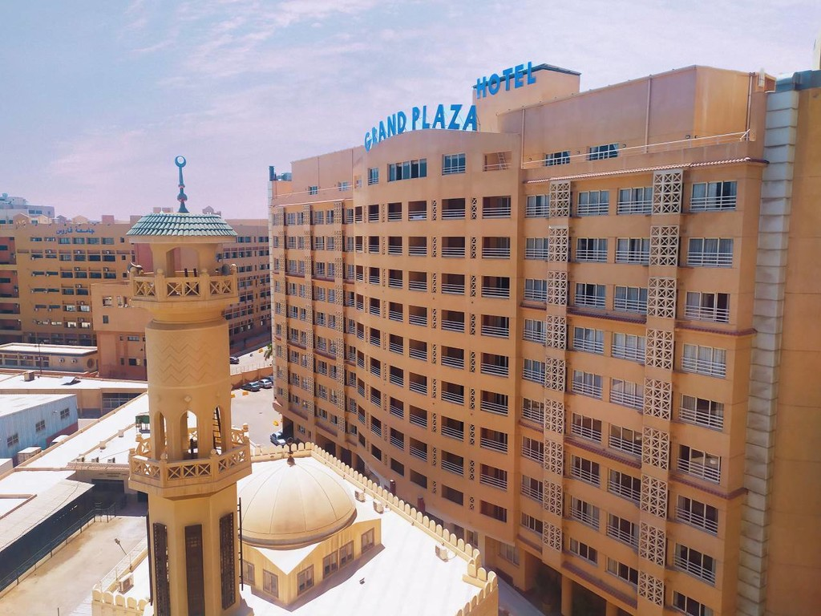
Website: https://www.tgphotels.com/

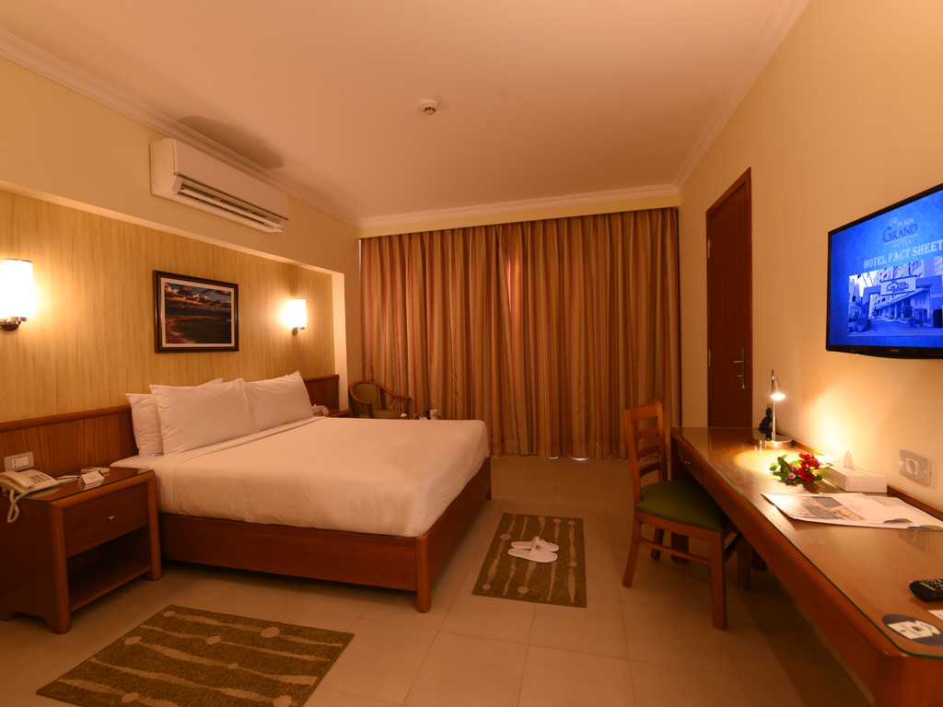
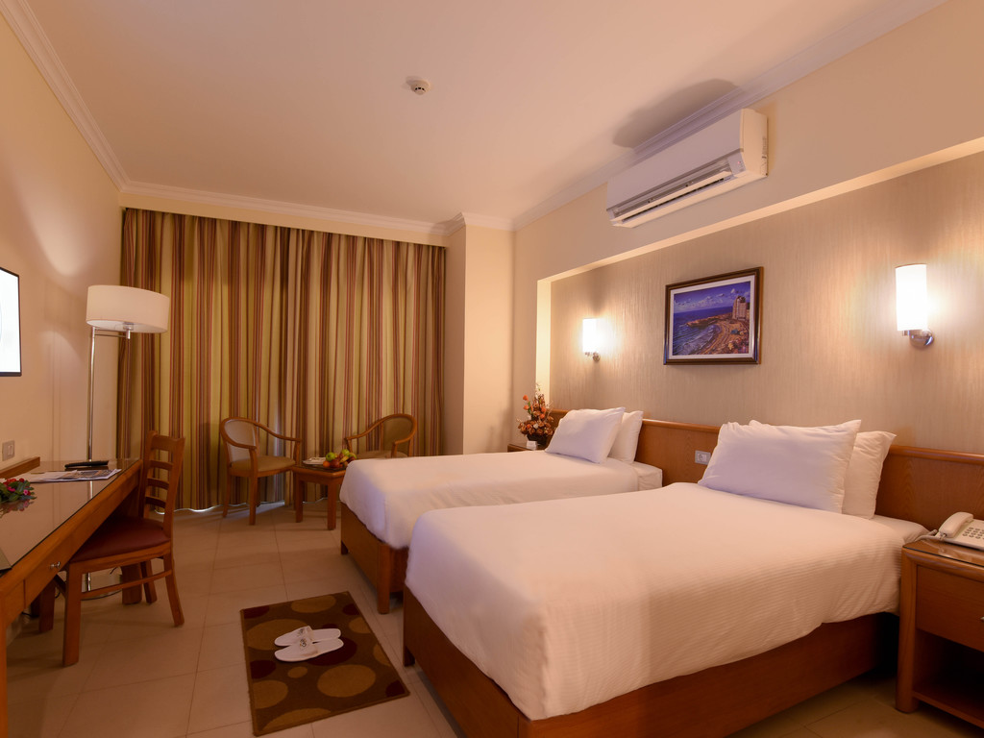
Official Nomination Form

The International Blind Sports Federation and The Egyptian Blind Sports Federation
Invite all IBSA member Federations to the:
16th IBSA World Powerlifting & Bench Press Championships
For Blind and Visually Impaired Athletes
Alexandria, Egypt
October 1 – 8, 2022

The preliminary and final nomination forms must be sent to: egyblindsports2016@gamil.com &
sergiocentenorodriguez@gmail.com
Submitted by

Submitting officer: |  | Title: |  | Date:

Team Manager : |  | Coach:

Referee 1 : |  | Cat : |  | Available for categories:
Referee 2 : |  | Cat : |  | Available for categories:
Referee 3 : |  | Cat : |  | Available for categories:

Total number of lifters: |  | Total amount of team : |  | Arrival : day : |  | Flight/train/car

Arrival time: |  | On airport/station: |  | Flight nr:

Departure time: |  | Time: |  | Flight nr:

We need rooms: |  |  | Single – from – to: |  |  |  | Double – from – to:

The National federation must designate which categories each nominated referee is available to referee at the championship. If nominated by the Technical Committee to referee at the championships, each referee must be available for the designated categories. Furthermore, it is an obligation of every Federation to confirm the participation of all their Referees nominated on the Final Nomination Form and/or cancel the referees who will not participate in the championship.

State each lifter’s personal best achieved at national or international championships during the previous 12 months.
Enter the lifter’s family name and first name separately into an appropriate column below.
Please, use each lifter’s full first name, not his or her nickname!

ACCREDITATION OF FEDERATION OFFICIALS/COACHES

Full and Complete Name | Title

Powerlifting Nominations – Open Men

Wt. Class | Family Name | Given / First Name | Birthday | Squat | Bench | Deadlift | Total
56
60
67.5
75
82.5
90
100
110
125
125+
Reserve lifters, Maximum 2 per team

Powerlifting Nominations – Junior Men

Wt. Class | Family Name | Given / First Name | Birthday | Squat | Bench | Deadlift | Total
56
60
67.5
75
82.5
90
100
110
125
125+
Reserve lifters, Maximum2 per team

Powerlifting Nominations–Masters Men / 40+ Men

Wt. Class | Family Name | Given / First Name | Birthday | Squat | Bench | Deadlift | Total
56
60
67.5
75
82.5
90
100
110
125
125+
Reserve lifters, Maximum 2 per team

Powerlifting Nominations – Open Women

Wt. Class | Family Name | Given / First Name | Birthday | Squat | Bench | Deadlift | Total
48
52
56
60
67.5
75
82.5
90
90+
Reserve lifters, max 2 per team

Powerlifting Nominations – Junior Women

Wt. Class | Family Name | Given / First Name | Birthday | Squat | Bench | Deadlift | Total
48
52
56
60
67.5
75
82.5
90
90+
Reserve lifters, max. 2 per team

Powerlifting Nominations–Masters Women / 40+ Women

Wt. Class | Family Name | Given / First Name | Birthday | Squat | Bench | Deadlift | Total
48
52
56
60
67.5
75
82.5
90
90+
Reserve lifters, max. 2 per team

Bench Press Nominations – Open Men

Wt. Class | Family Name | Given / First Name | Birthday | Squat | Bench | Deadlift | Total
56
60
67.5
75
82.5
90
100
110
125
125+
Reserve lifters, Maximum 2 per team

Bench Press Nominations – Junior Men

Wt. Class | Family Name | Given / First Name | Birthday | Squat | Bench | Deadlift | Total
56
60
67.5
75
82.5
90
100
110
125
125+
Reserve lifters, Maximum2 per team
Bench Press Nominations –Masters Men / 40+ Men

Wt. Class | Family Name | Given / First Name | Birthday | Squat | Bench | Deadlift | Total
56
60
67.5
75
82.5
90
100
110
125
125+
Reserve lifters, Maximum 2 per team

Bench Press Nominations – Open Women

Wt. Class | Family Name | Given / First Name | Birthday | Squat | Bench | Deadlift | Total
48
52
56
60
67.5
75
82.5
90
90+
Reserve lifters, max 2 per team

Bench Press Nominations – Junior Women

Wt. Class | Family Name | Given / First Name | Birthday | Squat | Bench | Deadlift | Total
48
52
56
60
67.5
75
82.5
90
90+
Reserve lifters, max. 2 per team

Bench Press Nominations – Masters Women / 40+ Women

Wt. Class | Family Name | Given / First Name | Birthday | Squat | Bench | Deadlift | Total
48
52
56
60
67.5
75
82.5
90
90+
Reserve lifters, max. 2 per team
address for contact:

Name: |  | Street: |  |  | Zipcode:
City: |  | Country: |  | Phone:
Fax: |  | E-mail:

VISA INSTRUCTIONS
If you require a letter of invitation to obtain a VISA to enter to the Egypt please send the completed VISA Support Document to Dr Ahmed Owain
‬Email : egyblindsports2016@gmail.com Phone : +201063325600
The Visa Support Document should include the each athlete/official/coaches complete and full name as indicated on their passport, birthday, passport number with the expiration date. The request should include the arrival and departure dates into the Egypt. It is very important that you apply as early as possible. Recommendation is to apply no later than 3 months prior to you leaving for your trip to Egypt

Visa Support Document
Country: _______________________________

Full names of athletes | Birth Day | Passport Number | Expiration Date
Full names of coaches | Birth Day | Passport Number | Expiration Date

__________________________________________ ______________________________________
(Signature) National Federation – General Secretary (Signature) National Federation President/Executive Officer

__________________________________________ ______________________________________
(Print) National Federation – General Secretary (Print) National Federation President/Executive Officer

Hotel Booking Form

Country: _______________________________

Visitors Name | Single (or) Double Room | Arrival Date | Departure Date | Breakfast Yes/No
Room 1
Room 2
Room 3
Room 4
Room 5
Room 6
Room 7
Room 8

__________________________________________ ______________________________________
(Signature) National Federation – General Secretary (Signature) National Federation President/Executive Officer

__________________________________________ ______________________________________
(Print) National Federation – General Secretary (Print) National Federation President/Executive Officer
Airline Arrival – Departure Form

Country: _______________________________

Name of Traveller | Airline | Flight Number | Arrival Date | Departure Date

__________________________________________ ______________________________________
(Signature) National Federation – General Secretary (Signature) National Federation President/Executive Officer

__________________________________________ ______________________________________
(Print) National Federation – General Secretary (Print) National Federation President/Executive Officer

The International Blind Sports Federation and The Egyptian Blind Sports Federation
Invite all IBSA member Federations to the:
16th IBSA World Powerlifting & Bench Press Championships
For Blind and Visually Impaired Athletes
Alexandria, Egypt
October 1 – 8, 2022

Flag and Anthem Approval

The below signatory confirms that the orientation and design of the country flag has been approved for use by an authorised representative. The authorised representative also confirms that the country anthem (national song) is endorsed for use.

Federation

Flag

Anthem | Please put your file (anthem – song) in attachment.

Notes

Name
Position
Date
Signed
Stamp

Please sign and return this form to egyblindsports2016@gmail.com and copy to nezamdodel@gmail.com and sergiocentenorodriguez@gmail.com no later than August 20, 2022
* Please note that this process serves the purpose of resolving any issues with regards to flags and anthems prior to your Nations arrival at IBSA World cup Alexandria, Egypt October 1-8, 2022

Form for Identification Cards

The International Blind Sports Federation and The Egyptian Blind Sports Federation
Invite all IBSA member Federations to the:
16th IBSA World Powerlifting & Bench Press Championships
For Blind and Visually Impaired Athletes
Alexandria, Egypt
October 1 – 8, 2022

Please place your picture in the box
Full name : _______________________
Nationality: _______________________
Position : _______________________

Please place your flag here

- Please attach all attached photos by e-mail in form of. JPG

